This framework provides guidance to assist member companies and the industry in developing or updating their facility’s Pandemic Response and Business Continuity Plan. SOCMA represents manufacturer, distributors and service providers in the specialty and fine chemical supply-chain. Working with its member companies and industry experts, SOCMA is developing general guidance and sample information as a reference for companies to use during a national pandemic declaration. The business landscape and circumstances are changing daily, and this document will be updated as SOCMA receives appropriate and relevant information. (Updated 3/19/2020)

- INTRODUCTION
- OBJECTIVES AND PLAN SUMMARY
- PANDEMIC RESPONSE
  - Pandemic Planning Team
    - Pandemic Continuity Coordinator
    - Communications Point-Of-Contact
    - Senior Management P-Of-Contact (external/employees)
  - Risk Communications: Internal and external stakeholders
  - Communication with local authorities
    - Specifics to the pandemic
    - Build your case for why your organization is essential - knowing that only essential business may be able to continue operations
  - Emergency Shutdown Procedures
    - Regular communications on process shutdown
    - Length of time needed
    - Minimum staffing requirements
  - Handling of materials (shipping/receiving)
    - Paperwork handled by drivers (tightened screening)
- PANDEMIC PLAN THRESHOLD
Assignment of task during phases of pandemic
  - Mitigation Triggers - Table 1
- CONTRACTORS/PARTNERS PANDEMIC PLAN MINIMUM REQUIREMENTS
All contractors/partners must meet the same standards as the operating facility
  - Initial Actions
  - Planned Actions
  - Recommended Next Steps
  - Pandemic Preparedness Checklist – Table 2
- SUPPLY CHAIN ACTIONS TO CONSIDER
  - Short Term Actions: 1 - 4 weeks
    - Understand exposure
    - Take actions to address anticipated shortages
    - Ensure resources required to restart
    - Develop supply-chain risk map
    - Understand additional options
  - Mid-Term Actions: 1 – 4 months
    - Continuously improve/assess supply chain and operational stability
    - Update supply-chain mapping plan
    - Build collaborative relationship with external partners
  - Long-Term Actions
- Understanding State/Local Restriction
  - Determining essential employees
  - Delivery restrictions
  - Determining critical infrastructure designations
- BEST HEALTH PRACTICES – PREPARING FOR AN INFECTIOUS DISEASE CRISIS
  - Guidance on Good Hygiene Practice
  - 10 Steps for Disinfection Protocols
  - Immediate Actions taken within the last 2 weeks
  - Procedure Template for Active Screening
  - Return to work protocols
  - CDC Pandemic Planning Checklist

- Appendix

TABLE 1: Mitigation Triggers
Table 1: Mitigation Triggers – Outline the industry’s threshold/triggers for implementing mitigation steps in response to escalating pandemic/epidemic concerns
Phase | Description | Response
0 | No pandemic concerns | - Implement normal good health practices (washing hands frequently, common areas cleaned routinely, hand sanitizer available in public areas, etc.)
1 | News of a specific potential pandemic threat is circulated by the World Health Organization (WHO) or the Centers for Disease Control (CDC) with reports of human cases outside of countries of operation. | - Monitor disease progress  - Review Company Pandemic Plan  - Provide generic disease information to employees as deemed appropriate
2 | News of a specific potential pandemic threat is circulated by the World Health Organization (WHO) or the Centers for Disease Control (CDC) with reports of human cases within countries of operation. | - Enact Company Pandemic Plan  - Begin non-invasive mitigation measures (wash hands more frequently, distribute hand sanitizer, clean common rooms more frequently, etc.)
3 | WHO or CDC reports that a pandemic disease is present within the country of operation, but no reported cases are present in the region/area of operation. | - Begin invasive mitigation measures (limit face-to-face meetings; reduce use of public transportation, etc.)
4 | WHO or CDC reports that a pandemic disease is present within the region/area of operation. | - Continue invasive mitigation measures (stop face-to-face meetings, restrict use of public transportation, implement PPE, etc.)
5 | Cases have been confirmed within company/location | - Implement aggressive mitigation measures (exercise work from home plans, reduce human interfaces, etc.)

TABLE 2: Pandemic Preparedness Checklist
Table 2: Pandemic Preparedness Checklist

Pandemic Continuity Coordinator: A pandemic disease plan or disease containment plan should be developed for the company and a coordinator appointed. Identify a workplace coordinator who will be responsible for dealing with disease issues and their impact at the workplace. This may include contacting local health department and health care providers in advance and developing and implementing protocols for response to ill individuals.
Personal Sanitization: Hand washing and use of alcohol-based hand sanitizers should be encouraged by company supervision. Hand washing facilities, hand sanitizers, tissues, no touch trash cans, hand soap and disposable towels should be provided by the employer.
Environment Sanitization: Clean all areas that are likely to have frequent hand contact (like doorknobs, faucets, handrails) routinely and when visibly soiled. Work surfaces should also be cleaned frequently using normal cleaning products.
Illness Prevention: Employees should be trained on health issues of the pertinent disease to include prevention of illness, initial disease symptoms, preventing the spread of the disease, and when it is appropriate to return to work after illness. Disease containment plans and expectations should be shared with employees. Communicating information with non-English speaking employees or those with disabilities must be considered.
Flexible Work Policies: Flexible work policies should be developed as possible. Workers should be encouraged to stay at home when ill, when having to care for ill family members, or when caring for children when schools close, without fear of reprisal. Telecommuting or other work-at-home strategies should be developed.
Business Continuity Planning: Business continuity plans should be prepared so that if significant absenteeism or changes in business practices are required business operations can be effectively maintained.
Immunizations: Workers should be encouraged to obtain appropriate immunizations to help avoid disease. Granting time off work to obtain the vaccine should be considered when vaccines become available in the community.
Internal Communications: Key contacts, a chain of communications and contact numbers for employees, and processes for tracking business and employees’ status should be developed.
External Communications: A procedure must be developed to notify key contacts including both customers and suppliers in the event an outbreak has impacted your company's ability to perform services. This procedure must also include notification to customers and suppliers when operations resume.
Social Distancing: Social distancing including increasing the space between employee work areas and decreasing the possibility of contact by limiting large or close contact gatherings should be considered.
Exercising: The plan and emergency communication strategies should be periodically tested (for example annually) to ensure it is effective and workable.

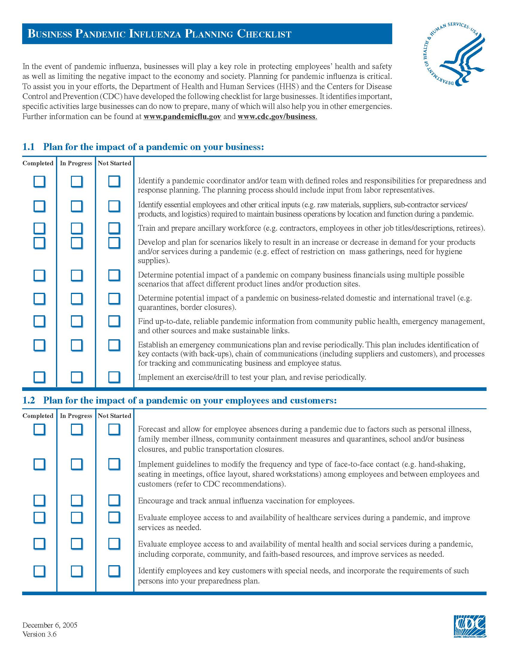
FEMA Business Pandemic Planning Checklist
